

**The 5th Call for proposals from**

**the Innovation Fund of the UL**

**2024**

Pursuant to Article 4 of the Rules on the management of the Innovation Fund of the University of Ljubljana, the Knowledge Transfer Office hereby issues

**the Call for proposals for the allocation of funds from the Innovation Fund of the UL**

*(Prove that it works!)*

Many innovative ideas at the University of Ljubljana (UL) are produced and manifested in various forms of intellectual property. In its strategic documents, the University has committed itself to transferring such intellectual property to the business sector, aiming to improve the quality of life both in Slovenia and abroad.

Long-term partnerships with the business sector and the ability to check how ideas are working within the University are important conditions for successful commercialisation of inventions.

**The purpose of this Call**

To support promising projects and help them achieve a higher technology readiness level (TRL), thus increasing the appeal of such technologies for potential buyers.

**RESULT OF THE INNOVATION FUND CALL FOR PROPOSALS**

The envisaged result of the projects, which will receive funds, is the increased Technology Readiness Level ([TRL](https://ec.europa.eu/research/participants/data/ref/h2020/wp/2014_2015/annexes/h2020-wp1415-annex-g-trl_en.pdf)) and higher level of value innovation, a greater chance of selling/licensing the innovation, creating connections with industrial partners, as well as improving the chances of successfully applying to bigger tenders to verify the concept.

**WHO CAN APPLY TO THE CALL FOR PROPOSALS**

The Call is intended solely for employees of the University of Ljubljana (with at least 50% employment at the University of Ljubljana) who would like to transfer to the market or to practical use specific technology or knowledge owned by the University of Ljubljana. In the event of several owners, the technology must be at least 50% owned by the University of Ljubljana (if there are two owners) or at least 30% owned by the University of Ljubljana (in the event of three or more owners).

If the team also comprises employees of another public research organisation and the technology/knowledge is co-owned with another public research organisation, such a team may also apply. This is permitted if the applicant encloses a statement by the partnering public research organisation, in which the latter expresses its consent that the received funds constitute a direct cost in marketing the technology, and that thus the commercialisation royalties shall first be used to cover these costs; only then shall the royalties be divided among the co-owners of the technology or other knowledge in accordance with the fifth paragraph of Article 8 of the Rules on the management of the Innovation Fund of the University of Ljubljana.

Young researchers and early career researchers who have an employment contract with UL as described above (including those receiving a postdoctoral fellowship) are eligible to apply and are also encouraged to do so.

An individual researcher may only participate with one project application.

Upon applying to the Innovation Fund Call, the innovation shall be developed at least to [TRL 3 (Experimental confirmation of the concept), but not more than TRL 6 (technology demonstrated in relevant environment).](https://ec.europa.eu/research/participants/data/ref/h2020/wp/2014_2015/annexes/h2020-wp1415-annex-g-trl_en.pdf)

Projects for which a license contract/assignment agreement of intellectual property rights has already been concluded or in relation to which a spin-out company has been established, are not eligible for application.

**WITH WHAT KIND OF PROJECT CAN I APPLY TO THE INNOVATION FUND CALL AND WHICH COSTS ARE ELIGIBLE?**

The Fund’s resources are used for projects of UL members in the field of knowledge transfer, which lack any of the following steps to the conclusion of a licensing/assignment contract, contract on joint development or application to a bigger tender to verify the concept: feasibility study, market potential research, working and tested prototype, confirmation of the functioning of the technology within an industrial/clinical environment, establishment of relations with the relevant businesses.

The Fund’s resources can be used to cover any of the following costs (eligible costs)[1]:

1. labour costs for a new/additional colleague at the UL (up to 20% of the funds received);
2. material costs **(cost of materials and services for the development and testing of a prototype, development of user interfaces;** **3D animations** to illustrate the mechanisms of the invention, process, etc.);
3. external costs (consultancy services, feasibility study, prototype production and testing services, costs of **pilot testing** (or testing in industrially relevant environment)); **obtaining of certificates or testing with external providers (e.g. validations in certified laboratories, various product analyses** (analyses of technological environment and market; LCA analyses; user tests, market potential analysis/research, etc.);
4. depreciation of equipment (up to 30% of the funds received);
5. participation or appearance at industrial fairs (**visiting industrial fairs or potential industrial partners).**

VAT constitutes an eligible cost.

The following costs shall be excluded from financing: labour costs of the inventors (UL employees), attendance at scientific conferences and purchase of materials and equipment for the implementation of basic research.

**HOW MUCH FUNDING IS AVAILABLE?**

The budget of the Innovation Fund for 2024/2025 is EUR 100,000 and is valid for the period from 1 November 2024 to 31 October 2025. The highest funding amount for an individual innovation project is EUR 25,000, and the lowest EUR 5,000.

**HOW DO I APPLY?**

**The application form** is divided into six main sections. Individual sections will be evaluated, with each section weighted for a certain number of points as described below. Within the sections, the criteria listed below shall be evaluated.

Project duration: from 6 months to 1 year from the date of signing the contract with UL (with the possibility of extension based on substantiated reasons).

Email your application form and the accompanying Call documentation to the Knowledge Transfer Office – [gospodarstvo@uni-lj.si](mailto:gospodarstvo@uni-lj.si).

Deadline for submission of applications: 29th August 2024.

**TIMELY AND COMPLETE APPLICATION**

The application shall be deemed timely if it was handed in within the deadline as set in the Call.

The application is complete if it contains all of the following mandatory components:

* completed application form, signed by the Project Manager and Dean of the UL Member (in Slovene or English);
* contract on the financing of the project with the Innovation Fund resources, initialled by the Project Manager and Dean of the UL Member;
* if the technology is co-owned with other public research organisations, a STATEMENT from such public research organisations and the inventors employed by them on the acceptance of the Call conditions;
* if the applicant states in the application that the project is supported by unrelated companies/organisations, letters of support by such companies/other organisations shall be enclosed, signed by the legal or authorised representative of the company/organisation;
* if the technology is to be tested in cooperation with an industrial partner (financial and in-kind contributions of the company), an agreement on cooperation shall be enclosed, which regulates the legal relationships with the industrial partner (particularly the intellectual property rights).

**WHO EVALUATES THE APPLICATIONS?**

The Evaluation Committee. It comprises members of the Knowledge Transfer Office and the University of Ljubljana’s Innovation Commission, the Ljubljana University Incubator and external evaluators - experts from the industry/investment circles.

**WHAT ARE THE EVALUATION CRITERIA?**

* Team references
* Innovativeness
* Market potential
* Feasibility of project proposal
* Rationality of the financial plan

The Evaluation Committee will evaluate the projects on the basis of the documentation received and rank them according to the number of points received. The 10 highest rated projects will be invited to present their technology at the evaluation panel.

Funds shall be allocated to projects with the highest score, upon the consent of the majority of the Evaluation Committee members and the Rector of the UL: The Committee shall have the right to allocate to the chosen projects amounts that are lower than those requested. The Committee/Rector reserves the right not to choose any project for financing.

The evaluation form is part of the Call documentation.

**WHAT IS THE PROCESS AFTER THE APPLICATION?**

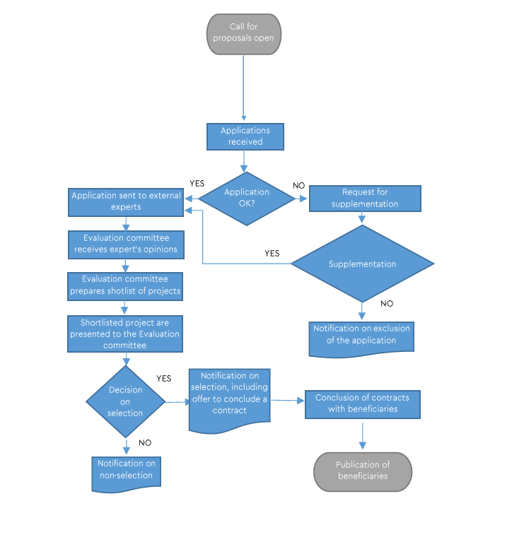

* The short-listed applicants will present their innovation projects (personally or via teleconference tools) to the Evaluation Committee.
* The evaluation results will be known no later than two (2) months after the expiration of the deadline for the submission of applications. Applicants will be informed about the selection/rejection of their projects in writing via e-mail.
* The selected applicants and the UL will sign a CONTRACT on the receipt of funds from the Innovation Fund of the UL (a sample of the contract forms an annex to the Call).
* Each project will be appointed a project supervisor, who will work with the respective applicants, making sure the project is being implemented appropriately and in line with the project proposal.
* After the project is completed, the fund Beneficiaries shall submit a final report on project implementation.
* The results of the projects selected in the Call will be presented publicly. Invitation to the final presentation will also be extended to the industrial and investment community.

**WHOM CAN I CONTACT IF I HAVE ADDITIONAL QUESTIONS?**

The Knowledge Transfer Office of the UL team is available to interested applicants for help, for guidance in preparing the application and for additional information:

* [gospodarstvo@uni-lj.si](mailto:gospodarstvo@uni-lj.si), +386 1 24 18 533
* [Polona.Juvancic@uni-lj.si](mailto:Polona.Juvancic@uni-lj.si), +386 70 466 559
* [Simona.Rataj@uni-lj.si](mailto:Simona.Rataj@uni-lj.si), +386 70 538 283.

Annexes:

1. Rules on the management of the Innovation Fund of the University of Ljubljana
2. Application form
3. Statement on the acceptance of conditions of the Call by another public research organisation
4. Draft contract on the financing of the project with the Innovation Fund resources
5. Final report form
6. Evaluation sheet

1. *The Evaluation Committee reserves the right to restrict or additionally change the set of financed activities in agreement with the applicant. One or several of the proposed activities may be financed, depending on the budget.*