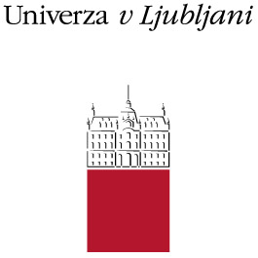

ERASMUS+ (STA)
Letter of Confirmation for Erasmus+ International Credit Mobility
Staff Mobility for Teaching

We hereby confirm that the below mentioned teacher from University of Ljubljana (Erasmus code:SI LJUBLJA 01), successfully accomplished the Erasmus+ Teaching Staff Mobility, as agreed in her/his Teaching Programme.

Teacher’s name and surname:

Name and address of Host institution:

Dates of start and end of the mobility period from : till:

Number of lecture hours:

Title(s) of lecture(s):

Other activities:

Number of students at the Host institution attending the lectures:

Level of students (First Cycle, Second Cycle, Third Cycle, Multiple Cycles):

Confirmation of the Host institution:

Name of responsible person and signature:

_ _ _ _ _ _ _ _ _ _ _ _ _ _ _ _ _ _ _ _ _ _ _ _ _ Stamp:
Position of responsible person at the Host institution:


_ _ _ _ _ _ _ _ _ _ _ _ _ _ _ _ _ _ _ _ _ _ _ _ _ Date:_________________

