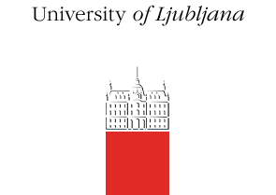
INTERNATIONAL STAFF TRAINING WEEK
UNIVERSITY OF LJUBLJANA
MAY 23rd – 27th, 2016

APPLICATION FORM

Please fill in the application form, send the signed and scanned version to kc@uni-lj.si by March 4th 2016, and the original to:
University of Ljubljana
Career Centres
Kongresni trg 12
SI-1000 Ljubljana

We will get back to you with the answer shortly after the application deadline. All personal data is gathered solely for the purpose of organising the International Staff Training Week, and will be processed and stored in accordance with applicable personal data protection laws.

Personal details
Title | □ Mr. □ Mrs. □ Ms.
Surname
First name
Contact address
Email
Telephone
Position
Main tasks/ responsibilities

Sending institution
University, faculty and department

Address

Motivation
Please, explain in a few sentences why you wish to take part in the international staff training week at the University of Ljubljana:

Information on interests
Date of Arrival:

Date of Departure:

Guided tour of Ljubljana  Tuesday, May 24th (free of charge) | YES NO
Boat trip on the Ljubljanica river  Thursday, May 26th (own expense*) | YES NO
Trip to Lake Bled,  Friday, May 27th (free of charge) | YES NO
Special requirements
Special dietary requirements
- None
- Vegetarian
- Other, please specify:

Please inform us in advance if you have a disability that requires us to provide special assistance:

Signature and stamp:
*Sightseeing costs:
- Boat trip on the Ljubljanica river: 8 Euros; more information about the boat trip HERE

