Global Warming: What We Can Do About It?

“The mother polar bear waits through another long winter. She comes out of hibernation weak and starving. She can almost smell her next meal: fresh seals swimming in the water on the edge of the ice cap”
When she crawls out of her den, followed by her two cubs, she’s looking much thinner than she did a few months ago. There is not a moment to lose. She needs to pack in as much energy as she possibly can. She’ll need to swim with her cubs to edge of the ice cap, and hunt for seal pups and other animals that are swimming near the edge. She is a good swimmer, but a hungry and weak Polar Bear can only swim so far. ("Global Warming: Melting kingdom of the polar bear" 2016)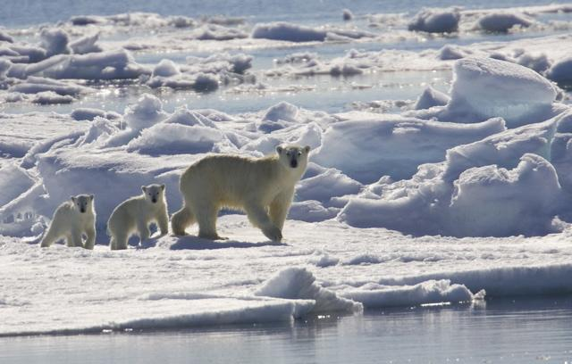
When she reaches the edge, she comes to see that the edge of the water is just a little bit closer this time. This is something that she sees each year. This is her new reality. Why is the ice pack shrinking? What’s happening? The answer is global warming.
What is “global warming?” It is part of climate change. Climate change is any big change in climate that lasts for an extended period of time. Global warming refers to climate change that causes an increase in the average temperature of the lower atmosphere. Global warming can have many different causes, but it is most because of human interference and human activity creating great amounts of greenhouse gases.
Greenhouse gases included gases like carbon dioxide (CO₂), what we breath out, methane (CH₄), water vapor, and fluorinated gases. These gases create a “greenhouse” around the earth. This means that they let the heat from the Sun into the atmosphere, but keep the heat in, not letting it go back into space. The more greenhouse gases there are, the larger the percentage of heat that is trapped inside the earth’s atmosphere. The earth could not exist some naturally occurring greenhouse gases, such as CO₂, CH₄, and water vapor. If we didn’t have any greenhouse gases no heat would be trapped in atmosphere, and the earth would be very cold and not be able to support life.
The global warming around the world over the past 50 years can only be explained by the results of human influences, like burning fossil fuels (coal, oil, and natural gas) and from deforestation. Scientists know that human influences are the primary reason for climate change because of evidence. The first evidence is our fundamental understanding of how certain gases trap heat, how the climate system responds to increases in these gases, and how other human and natural factors influence climate. The second evidence is from reconstructions of past climates using evidence such as tree rings, ice cores, and corals. These show that global surface temperatures over the last several decades are not normal, with the last decade (2000-2009) warmer than any time in at least the last 1300 years and perhaps much longer.
“The current warming trend is of particular significance because most of it is extremely likely (greater than 95 percent probability) to be the result of human activity since the mid-20th century and proceeding at a rate that is unprecedented over decades to millennia” ("Climate Change Evidence: How Do We Know?" 2019)
One of the most apparent and obvious signs of global warming is the ever increasing sea level.
Global sea level rose about 8 inches in the last century. The rate in the last two decades, however, is nearly double that of the last century.
So what do we do about it?
Attending a conference to discuss alarming new data on rising sea levels, a weary group of top climatologists suddenly halted their presentation Friday, let out a long sigh, and stated that the best thing anyone can do at this point is just try to enjoy the next couple decades as much as possible

Bibliography
"Global Warming: Melting kingdom of the polar bear" 2016.” – Pitara Kids Network, 31 Aug. 2016, https://www.pitara.com/science-for-kids/planet-earth-for-kids/global-warming-melting-kingdom-of-the-polar-bear/.

“Climate Change Evidence: How Do We Know?” NASA, NASA, 9 July 2019, https://climate.nasa.gov/evidence/?cv=1.

